Content team cheat sheet

This is a living document for members of the content team to keep track of how to do certain tasks in Drupal. We will add to this when the need arises.

**Anchor links**

When you’re linking within the same page and not using the TOC content block within Drupal:

1. Open the preview of the page.

1. Highlight the H2 you want the anchor link to go to. Open up Inspect within the developer’s tools (On a Mac it’s Option + Right Click)

1. In the blue highlight grab the H2 id. You want everything inside the quotation marks, so in this example it’s: **a-legacy-appeal-follows-these-**

1. In edit mode, highlight the text you want to add the anchor link to, use the linking button, add a # before the H2 id you highlighted and save. Example: #**how-to-use-the-rate-tables-to**

When you’re using an anchor link to go to another page:

1. Follow all the steps above through 4.
2. In edit mode, highlight the text you want to add the anchor link to, use the linking button, use the full URL and add # with the H2 id: <https://www.va.gov/decision-reviews/legacy-appeals/#a-legacy-appeal-follows-these->

**Aria labels**

All phone numbers and TTY numbers should have an aria label around them for accessibility purposes. The coding is as follows:

Aria labels with links for phone numbers. Note that there is a 1 before the number only within the coding but not visible on the page:

:

<a href="tel:18008271000" aria-label="8 0 0. 8 2 7. 1 0 0 0.">800-827-1000</a>

Aria labels with links for TTY numbers:

<a href="tel:711" aria-label="TTY. 7 1 1.">TTY: 711</a>

How to style this in a WYSIWYG field:

1. If the number is already linked, click the unlink button.
2. Click Source so you can see the text with coding.

1. Add the aria label code to the text and input the correct numbers.
2. Click Source again so text is back to regular mode and you can see that the number is linked.

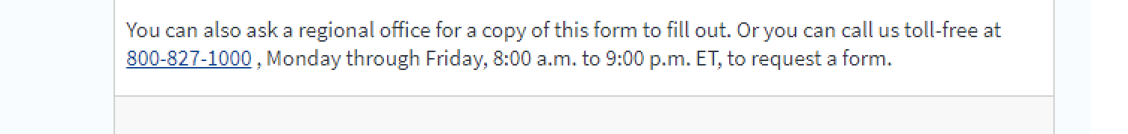

**How to format a button in Drupal**

1. Use the link button to input the corresponding URL to the text.

1. Highlight the link and click on Styles. Primary link button will create a green button; Secondary link button will create a blue button. A screenshot of a social media post

   Description automatically generated

